Certain important commands in command line Command Line Windows and Git/Github

Creating a new folder



Changing directory



Creating an empty file inside the folder



Checking all the folders and files inside

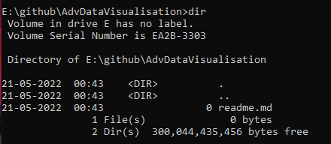

Open file using notepad



git init



git status

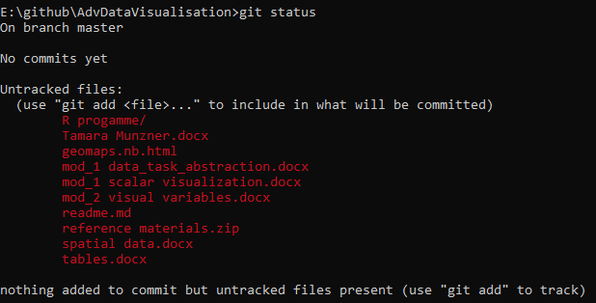git add .

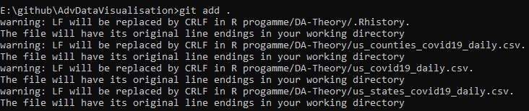

git status

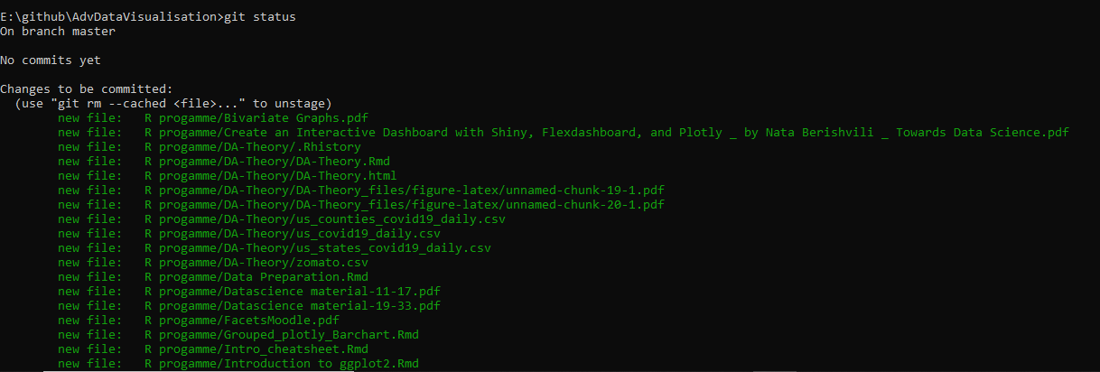 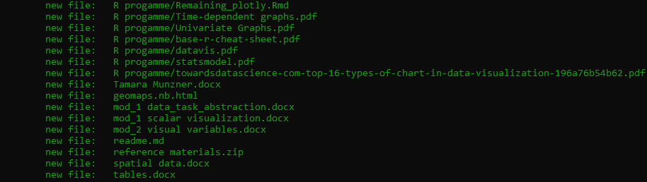

git commit -m “”

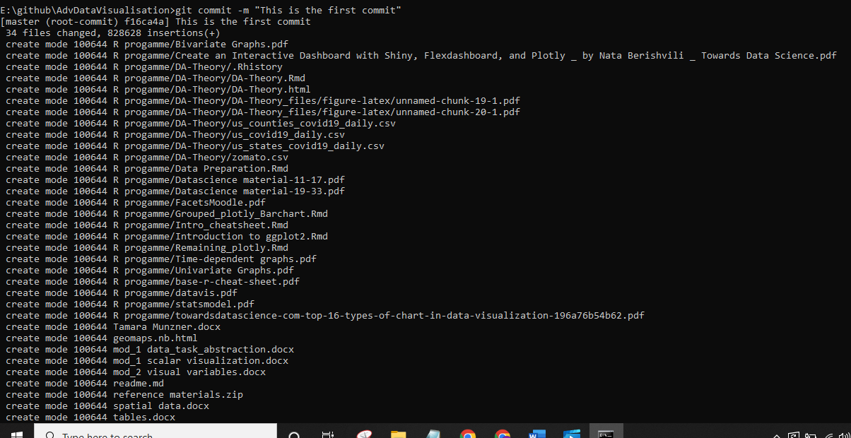

Linking our document to one creted by github



Pushing changes to the repo

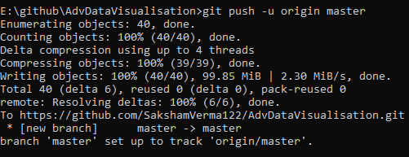

If you change something in any of the files

